**In Class Activity Lesson 2**

**Instructions:**

For this in-class activity, you will write a Python script for each of the questions. Please make sure that the submitted script runs without any errors. To receive full credit, the scripts must generate the correct outputs. Avoid including code from upcoming chapters.

**Submission Guidelines:**

1. Create a new cell for each question in Google Colab.
2. Submit your assignment as a .py file.

By following these instructions, you will demonstrate your understanding of the concepts covered and your ability to implement Python scripts to solve the given problems. Remember to adhere to the given guidelines for proper assessment.

Best of luck with the activity! 🐍

**Questions**

1. We have a triangle, and we want to calculate its area. First, assign the length of the base of the triangle to the variable name base, and assign the height of the triangle to the variable name height. Using the assigned values of base and height, calculate the area of the triangle and display it on the screen. The triangle we want to calculate the area for has a base length of 10 cm and a height of 4 cm.
2. Suppose you have a vegetable garden that is 50cm in length and 80cm in width. If you want to enclose the entire garden with a fence, and each fence length is 15cm, how many fences would you need to cover the whole garden?

Write a new Python script to solve this problem. Begin with defining variables fenceLength and gardenPerimeter, and then create a statement that calculates how many fences would be needed. Finally, print the final result.

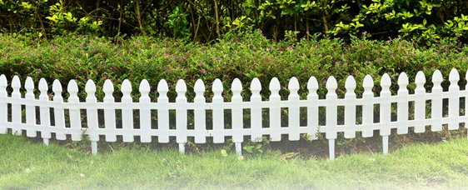

1. Write a Python script to calculate the number of quarters, dimes, and dollars required to represent 835 cents.

Your task is to create a Python program that takes the total amount in cents (835 cents in this case) and converts it into the equivalent number of quarters, dimes, and dollars. Utilize integer division (//) and the remainder operator (%) for this calculation.

For instance, when given 835 cents, the program should output something like:

Total Amount: 835 cents

Quarters: 1

Dimes: 1

Dollars: 8

You can just show number of cents after quarters, dimes and dollars, don’t need to do nickels and pennies (you can if you want, it is the same logic)

1. Write a Python program that prints the following pattern using escape characters:

One

Two

Three

1. Write a Python program that asks the user for their name and prints the following message using escape characters:

"John" is a common name.

1. Write a Python program that defines a file path using escape characters and prints it:

C:\Users\Documents\MyFile.txt